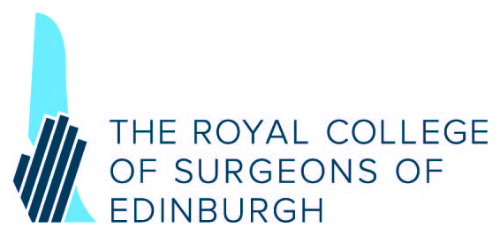

OPHTHALMOLOGY RESEARCH GRANTS
(Sponsored by Royal Blind)

- Major project grants (up to £60,000)
- Small Research Support Grants for ongoing research (up to £10,000)

Applications for funding under the above categories are invited from Ophthalmologists currently working in Scotland and all Fellows/ Members of the College in good standing, undertaking research projects in the UK.

The closing date for receipt of applications is Wednesday 21 November 2018

Applicants must use the current application form this can be downloaded from the College website or email Cathy McCartney Awards and Grants Administrator.

Further details and application forms can be obtained from:
Research & Grants Co-ordinator
Development & Partnerships Office
The Royal College of Surgeons of Edinburgh
Nicolson Street
Edinburgh
EH8 9DW
Tel: 0131 527 1618; email: c.mccartney@rcsed.ac.uk
www.rcsed.ac.uk

