FOUNDED 1911

AUTUMN MEETING

FRIDAY 15 SEPTEMBER 2023

STIRLING COURT HOTEL



Local Organisers and Hosts - NHS Grampian

Please visit our website for future meeting details
www.s-o-c.org.uk

President: Dr Christopher Scott, Hon Secretary: Dr Harry Bennett
Council Members: Dr Caroline Cobb, Dr Suzannah Drummond, Dr Andrew Ferguson, Dr Jan Kerr, Dr Cliff Weir, Dr Peter Wilson
Website Host/Junior Member : Dr Kim Ah See, Administration: Alison Simpson

WELCOME
Dr Chris Scott and the SOC Council extend a warm welcome to all delegates, speakers and members of commercial companies, attending the Autumn Meeting. We hope this will be a very successful event and wish you an enjoyable day. Prior to the meeting commencing, please take time to read the information below. If you have any queries regarding the meeting, please speak to Alison Simpson or Genna Allan at the Registration Desk.

GENERAL INFORMATION
Stirling Court Hotel has 150 complimentary car parking spaces operated on a first come first serve basis. A barrier system is in operation however guests must also input their car registration number immediately upon entering the hotel. If you don’t submit your car registration on arrival this will result in a private parking notice. Should the Hotel car park be full upon arrival, guests may use the car parks on Main Campus which are chargeable per day from 9.00am – 5.00pm Monday to Friday. Please see the link below for more details :https://www.stirlingvenues.com/visiting-us/find-us-parking

There will be no planned fire alarm tests during the meeting. In the unlikely event of a fire alarm sounding (a high pitched continuous tone will be heard or automated voice message) please make your way to the nearest emergency exit. Staff will be on hand to assist.

SECURITY
Security personnel are in place throughout the building. Name badges should be worn at all times. If you lose or misplace your badge at any time over the event, please report this to Alison Simpson or Genna Allan at the Registration Desk situated in the foyer.

REGISTRATION
Registration will take place in the foyer from 9.00 am. All delegates must be pre-registered. Due to catering number we are unable to register delegates on the day.
SOC GOES GREEN
A Council decision was made to save the environment by stopping printing SOC programmes and giving out plastic folders. Name badges have already been recycled for many years. The programme for today’s meeting will be on the screen, along with the AGM agenda. A copy of the programme is also available on the SOC Website www.s-o-c.org.uk

WEBSITE www.s-o-c.org.uk
Online registration and payment facilities are available. Please visit the website for further details. Comments/suggestions for future meetings etc can be sent via the website.

CATERING
We have tried to ensure dietary needs have been catered for. If you have any questions, please consult a member of the catering team in the Abbeycraig Restaurant. Teas and Coffees will be provided in the Blair Atholl Suite with lunch in the Abbeycraig Restaurant.

TECHNICAL PRODUCTION/SPEAKER PREVIEW
If you are presenting, as previously instructed, please ensure you contact our AV Technician, Jim Talbot, in the Wallace Monument Suite, who will be in attendance throughout the conference.

COMMERCIAL SPONSORSHIP
We are grateful to Maureen Wright and Jonathan Wright of JWiOpening Projects Ltd for organising the Trade Exhibition today. Thanks also to all the exhibitors for their continued sponsorship of the SOC. Please take time to visit these exhibits.

FUTURE MEETINGS
The Spring 2024 Meeting will be held on Friday 23 February in the Marriott Hotel, Glasgow. Hosts for this meeting NHS Lanarkshire. Further information will be available via the website www.s-o-c.org.uk or from Alison Simpson - alison.simpson3@nhs.scot or 01382 632713.

09:00 REGISTRATION
COFFEE

09:30 WELCOME – DR CHRISTOPHER SCOTT – SOC PRESIDENT

SESSION 1 FREE PAPERS CHAIR : DR CHRIS SCOTT AND DR HARRY BENNETT

09:45 Patients Perspective on an Innovative Use of QR Code Linked Patient Information Video on Cataract Surgery
W Ong, J Ashby, J Ellis

09:52 Tape Splint Tarsorrhaphy in the Treatment of Persistent Corneal Ulcer
M Stewart, D Lyall

09:59 ORA versus GAT, Devices Under Pressure
S Yap, S Gillan

10:06 Bilateral Spontaneous Descemet Membrane Detachment Following Uncomplicated Same Day Bilateral Simultaneous Phacoemulsification
O Erikitola, A Sekaran, V Zhang, C Diaper, D Anijeet

10:13 Retrospective Analysis of Corneal Scrape Outcomes in NHS Ayrshire & Arran
A Blake, J Nairn, P Robertson, Z Koshy

10:20 QUESTION AND ANSWERS

10:30 Neuro Imaging for the Ophthalmologist
Dr Asha Neelakantan, Consultant Radiologist, NHS Grampian

11:00 COFFEE
POSTERS AND TRADE EXHIBITION

SESSION 2 CHAIR : DR NICK GEORGE AND DR PETER WILSON

11:30 College Update
Professor Ben Burton, President of the Royal College of Ophthalmologists

12:00 Functional Visual Loss
Professor Ben Burton, Consultant Ophthalmologist, Great Yarmouth

12:30 SOC TRAVEL AWARD WINNER 2022 – DR CHRIS SCOTT
Dr Obaid Kousha, NHS Tayside

12:40 LUNCH
TRADE EXHIBITION
13:30 POSTER JUDGING

SESSION 3 CHAIR : DR ARAVIND REDDY AND DR JAN KERR

POSTER RAPID FIRE 2 MINUTE PRESENTATION (1 MINUTE SET UP)

13:45 Should Adjuvant External Beam Radiotherapy Always Be Used Post Enucleation For Patients With Uveal Melanoma and Extraocular Extension?
W Purcell, R A Eleuteri, H Heimann

13:48 The Use of Anakinra in the Management of Ocular Surface Inflammation Secondary to X-linked Chronic Granulomatous Disease
S Ahmed, D Lyall

1£:51 Evaluation of Acanthamoeba Keratitis Cases in the West of Scotland : A 12-Year Study
O Erikitola, M Sevgi, A Peckacka, U Harley, C Alexander, D Anijeet

13:54 Evaluation of Referral to Treatment Pathway from Diabetic Eye Screening to Ophthalmology in NHS Grampian
K Jamieson, P Patwari, C Santiago

13:57 A Comparative Audit of Consultant-Led Versus Allied Health Professional-Led Selective Laser Trabeculoplasty Outcomes in North-East Scotland
F Paul, K McEwing, G Porteus, Z Curtis, S Bhatta

14:00 Performing Descemet Membrane Endothelial Keratoplasty (DMEK) Corneal Transplantation With the Use of an Endoglide Pull-Through Insertion Device (E-DMEK)
E Boulton-Jones, H Al-Hayouti, D Lyall

14:03 A Comparison of Entropion Surgical Correction Techniques : A Retrospective Case Review
C Mulholland, S Drummond

14:06 Cataract Surgery Patient Information Leaflet in NHS Ayrshire and Arran
A Blake, W Chew, S Tuteja, B Lim, Z Koshy

14:09 Accuracy of Biometry Formulae in Predicting Cataract Surgery Refractive Outcomes After LASIK Surgery
N Nalagatla, P Wilson

GUEST SPEAKER

14:15 Retinopathy of Prematurity : Now and Onwards
Miss Gill Adams, Consultant Ophthalmologist, Moorfields Eye Hospital, London

FREE PAPERS

14:45 Aqueous Misdirection Syndrome (AMS)
F Hassan, Z Curtis, S Bhatta

14:52 Agreement of Trabecular Meshwork Identification in 360 Colour Gonioscopy Images
C Barbour-Hastie, S Deol, S Gillan, M Trucco, A Tatham

14:59 Time Requirements for Mandatory Cataract Simulation Modules
T McClay, D Lockington

15:06 Optimising Patient Flow and Efficiency in Ophthalmology : Lessons from an Audit on De-Coupled Clinics for Multimodal Imaging
N Hindi, M Das

15:15 QUESTIONS AND ANSWERS

15:20 TEA
POSTERS AND TRADE EXHIBITION

15:45 PRESENTATION OF PRIZES – DR CHRIS SCOTT
PRESENTATION OF SOC PAPER AND POSTER PRIZE

SESSION 4 CHAIR : DR SUDIPTO BHATTA AND DR DONALD MONTGOMERY

GUEST SPEAKERS

15:50 The Eye Health Network
Mr Stephen McPherson, Community Optometrist, NHS Grampian
Dr Chris Scott, Consultant Ophthalmologist, NHS Grampian

16:15 Preventing Glaucoma Blindness
Professor Anthony King, Consultant Ophthalmologist, Nottingham

16.55 CLOSING REMARKS AND THANKS
DR CHRIS SCOTT, SOC PRESIDENT

CERTIFICATES OF ATTENDANCE

Certificates of Attendance for the Autumn SOC meeting will be supplied electronically. You will be sent your certificate after you complete the online feedback form.

The online feedback form can be reached via the SOC homepage:

http://www.s-o-c.org.uk/index.php

Or via this QR Code

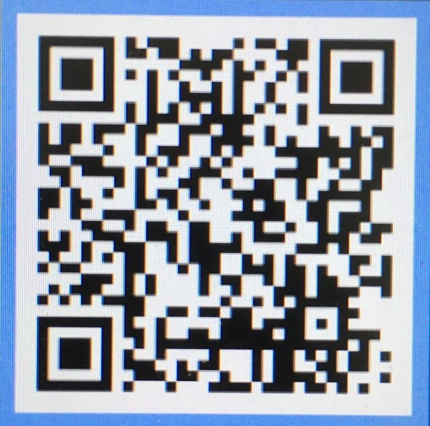

After you complete and submit the form you will then be sent your certificate of attendance by the SOC team.

PLEASE NOTE THIS FACILITY WILL ONLY BE VALID FOR
6 WEEKS POST MEETING

