FOUNDED 1911

AUTUMN MEETING

FRIDAY 20 SEPTEMBER 2024

APEX CITY QUAY HOTEL, DUNDEE

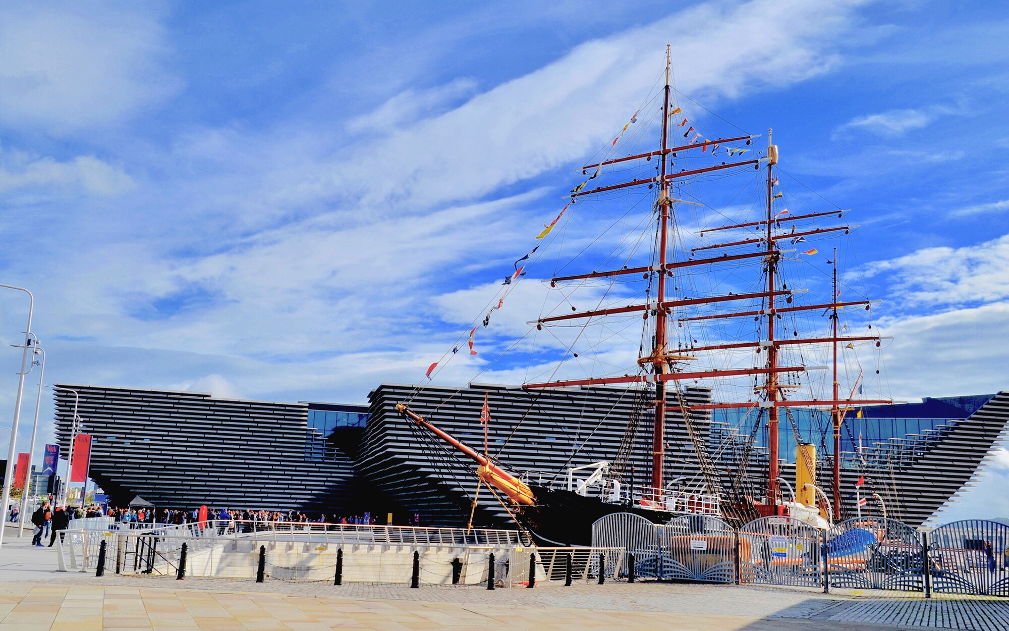

Local Organisers and Hosts - NHS Fife

Please visit our website for future meeting details
www.s-o-c.org.uk

President: Dr Donald Montgomery, Hon Secretary: Dr Harry Bennett
Council Members: Dr Stephen Burgess, Dr Caroline Cobb, Dr Suzannah Drummond
Dr Andrew Ferguson, Dr Jan Kerr, Dr Chris Scott, Dr Peter Wilson, Dr Cliff Weir
Website Host/Junior Member : Dr Kim Ah See, Administration: Alison Simpson

WELCOME
Dr Donald Montgomery and the Scottish Ophthalmological Club Council extend a warm welcome to all delegates, speakers and members of commercial companies, attending the Autumn Meeting. We hope this will be a very successful event and wish you an enjoyable day. Prior to the meeting commencing, we would be grateful if you could take time to read the information below. If you have any queries regarding the meeting, please speak to Alison Simpson or Genna Allan at the Registration Desk in the foyer.

GENERAL INFORMATION
There will be no planned fire alarm tests carried out whilst delegates are in the building. In the unlikely event of a fire alarm sounding (a high pitched continuous tone will be heard or automated voice message) please make your way to the nearest emergency exit. Disabled people should make their way, where possible, to the front of the building. Anyone who has special needs, in the event of an emergency, should make themselves known to the Apex Hotel staff on arrival. Please exit the hotel in an orderly manner and the hotel and staff will be on hand to assist.
Car Parking – please can you register your vehicle registration number at the hotel reception on arrival.

SECURITY
Security personnel are in place throughout the building. Name badges should be worn at all times. If you lose or misplace your badge at any time over the event, please report this to Alison Simpson or Genna Allan at the Registration Desk situated in the foyer.

REGISTRATION
Registration will take place in the foyer from 8.30 am. All delegates must be pre-registered. Due to catering number we are unable to register delegates on the day.
SOC GOES GREEN
A Council decision was made to save the environment by stopping printing SOC programmes and giving out plastic folders. Name badges have already been recycled for many years. The programme for today’s meeting will be on the screen, along with the AGM agenda. A copy of the programme is also available on the SOC Website www.s-o-c.org.uk

WEBSITE www.s-o-c.org.uk
Online registration and payment facilities are available. Please visit the website for further details. Comments/suggestions for future meetings etc can be sent via the website.

CATERING
We have tried to ensure dietary needs have been catered for. If you have any questions, please consult a member of the catering team in the Quayside Bar and Grill. Teas and Coffees will be provided in the City Quay Suite with lunch in the Quayside Bar and Grill.

TECHNICAL PRODUCTION/SPEAKER PREVIEW
If you are presenting, as previously instructed, please ensure you contact our AV Technician, Jim Talbot, in the City Quay Suite, who will be in attendance throughout the conference.

COMMERCIAL SPONSORSHIP
We are grateful to Maureen Wright and Jonathan Wright of JWiOpening Project Ltd for organising the Trade Exhibition today. Thanks also to all the exhibitors for their continued sponsorship of the SOC. Please take time to visit these exhibits.

FUTURE MEETINGS
The Spring 2025 Meeting will be held on Friday 21 February in Stirling Court Hotel. This meeting will be hosted by NHS Forth Valley. Further information will be available via the website
www.s-o-c.org.uk or from Alison Simpson - alison.simpson3@nhs.scot or 01382 632713.

09:00 REGISTRATION
REFRESHMENTS
POSTERS AND TRADE EXHIBITION

09:25 WELCOME – DR DONALD MONTGOMERY – SOC PRESIDENT

SESSION 1 FREE PAPERS

CHAIR : DR DONALD MONTGOMERY AND DR ANDREW FERGUSON

09:30 A Safe Specialist Nurse Led Cross linking Service - The Aberdeen Experience
Z Amir, E Ginsburg, L Taylor, Z Muhammad, A Reddy, R Stewart

09:37 Optimized Pathways for Suspected GCA : An Eye Clinic Audit
S Sadanandan, S Madill

09:44 An 8-year Analysis of Cataract Surgery Refractive Outcomes at the Golden Jubilee National Hospital
G Fenech, C Somerville, C Cox, G Cormack, S McLaughlin

09:51 No Drops after Cataract Surgery : A Patient Centred Approach – Feasibility Study
K Jamieson, J Ellis

09:58 Bridging the Gap : Optimising Induction for New Trainees across Scotland with the ‘Ophthalmology Boot Camp’
D Beck, P Wilson

10:05 An Audit of Corneoscleral Rim Culture from Donor Transplant Tissue for Patients
Undergoing Corneal Transplantation Surgery
V Tjen, D Lyall

10:12 Real-World Experience of Intravitreal Faricimab Injection in Previously Treated
Neovascular Age-Related Macular Degeneration Eyes
M Bantounou, M Elsheikh, A Ijasan, C Santiago

10:19 Systematic Review on the Safety and Efficacy of Ranibizumab Port Delivery System
in the Treatment of Neovascular Age-Related Macular Degeneration
K Ang, J Ang, P Cackett, B Dhillon
10:26 Enhancing Intra-operative Decision Making : A Conversion Table for Assisting Correct 3-Piece IOL Selection During Cataract Surgery Complications
C Ho, J Cuthbertson, D Lyall

10:33 Lipaemia Retinalis in Diabetic Patients with Severe Dyslipidaemia : A Report of 2
Cases
B Staniszewski, O Sivanesan, O Kousha, S Tarafdar

10:40 Phacoemulsification and IOL insertion Outcomes in Nanophthalmic Eyes
J Hazelwood, P Wilson

10:50 QUESTIONS

11:00 REFRESHMENTS
POSTERS AND TRADE EXHIBITION

SESSION 2 CHAIR : DR NIKKI HALL AND DR JAN KERR

GLOBAL OPHTHALMOLOGY

11:30 Integrating Eye Health into Child Health Programmes : A Case Study from Tanzania
Dr Aeesha Malik, Consultant Paediatric Ophthalmologist
School of Hygiene and Tropical Medicine, London

11:55 Frugal Technology for Eye Care : The Arclight Project
William J Williams, Honorary Senior Lecturer, University of St Andrews

12:15 History of Computer Games in Dundee : Past to Present
Jamie Bankhead, Konglomerate Games

12:35 QUESTIONS

12:45 SOC TRAVEL AWARD WINNER 2024 – DR DONALD MONTGOMERY

SOC TRAVEL AWARD WINNER 2023
Dr Obaid Kousha, NHS Tayside

13:00 LUNCH
POSTERS AND TRADE EXHIBITION
13:45 POSTER JUDGING

SESSION 3 CHAIR : DR HARRY BENNETT AND DR PETER WILSON

EDUCATION IN OPHTHALMOLOGY

14:00 Royal College of Ophthalmologists – Online Education – Inspire
Ms Melanie Corbett, Consultant Ophthalmologist
Digital Learning Lead, Royal College of Ophthalmologists

14:20 Vision 2020 Education Link in Indonesia
Dr John Ellis, Consultant Ophthalmologist, NHS Tayside

14:40 Inter-Professional Education in Eye Care – Rwandan Perspectives
Fiston Kitema, Ophthalmic Clinical Officer

15:00 Cerebral Visual Impairment – Resources to Improve the Public Understanding
Helen St Clair-Tracey, Honorary Lecturer, St Andrews University

15:20 QUESTIONS

15:30 REFRESHMENTS
POSTERS AND TRADE EXHIBITION

15:55 PRESENTATION OF PRIZES – DR DONALD MONTGOMERY
PRESENTATION OF SOC PAPER AND POSTER PRIZE

SESSION 4 CHAIR : DR DONALD MONTGOMERY AND DR ANDREW BLAIKIE

16:00 "Simulation for Training in Scottish Ophthalmology : An Update"
Dr Peter Wilson, Consultant Ophthalmologist, NHS Fife

16:20 THE GREAT DEBATE

“This house believes Scotland should select trainees for Scotland
versus national selection on training”

FOR – Dr Andrew Pyott, Consultant Ophthalmologist, NHS Highland

AGAINST – Ms Melanie Corbett, Consultant Ophthalmologist
Education Committee, Royal College of Ophthalmologists

16.50 CLOSING REMARKS AND THANKS
DR DONALD MONTGOMERY SOC PRESIDENT

Corporate Sponsors – Autumn 2024





























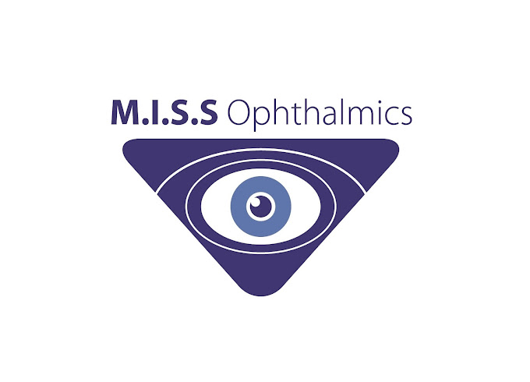

POSTER PRESENTATIONS

- A Rare Aand Aggressive Csae Of Orbital Histocytosis
N O’Connell, A Lewis, M Brougham, T Chan
- Are Acrylic IOLs Safe to use in Patients with Reported Methyl Methacrylate Allergy?
R Khalil, D Lockington

- Real World Outcomes from Hydrus Minimally Invasive Glaucoma Surgery
G George, M Rahman

- Review of Outpatient Management of Lower Lid Involutional Entropion with Everting Sutures
Y Ng, H Murgatroyd

- ST3 Skills Mastery : Skill Enhancement Through an Intensive Two-Day Course
D Beck, P Wilson, N Nalagatla, C Ogundo

- Cosmetic Eyelid Tape for the Non-Surgical Management of Eyelid Ptosis in a Patient with Chronic Progressive External Ophthalmoplegia (CPEO)
B Shahin, J Foulds

- When “Atypical NA-AION” Turns out to be Optic Neuritis
L Tan, G Mignot, S Chetty

- A Review of NHS Tayside’s Glaucoma Waiting List for New Patients - Who is being Seen?
J McKeever, G Somerville, C Cobb

- Local Audit on the Outcomes of Treatment-Resistant Neovascular Age-Related Macular Degeneration Switched from Aflibercept to Faricimab
A Katsimpris, M Das

- Inverse Occlusion: First Line Treatment for Eccentric Fixation in Childhood Strabismus
A Fernie, L Pentland, M Ullah

- Bilateral Orbital Myositis Suspected of being Triggered by a Pneumococcal Vaccination
B Staniszewski, T Thomson, H Murgatroyd

CERTIFICATES OF ATTENDANCE

Certificates of Attendance for the Autumn SOC meeting will be supplied electronically. You will be sent your certificate after you complete the online feedback form.

The online feedback form can be reached via the SOC homepage:

http://www.s-o-c.org.uk/index.php

Or via this QR Code

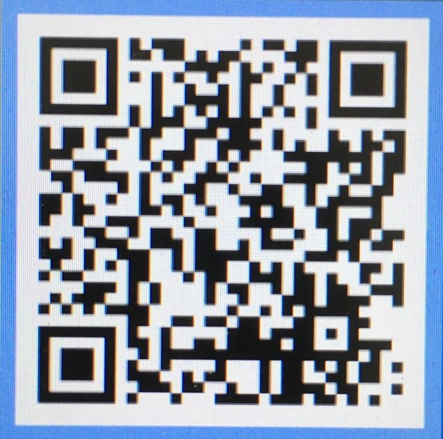

After you complete and submit the form you will then be sent your certificate of attendance by the SOC team.

PLEASE NOTE THIS FACILITY WILL ONLY BE VALID FOR
6 WEEKS POST MEETING

