Scholarships for Future Leaders in Ophthalmology
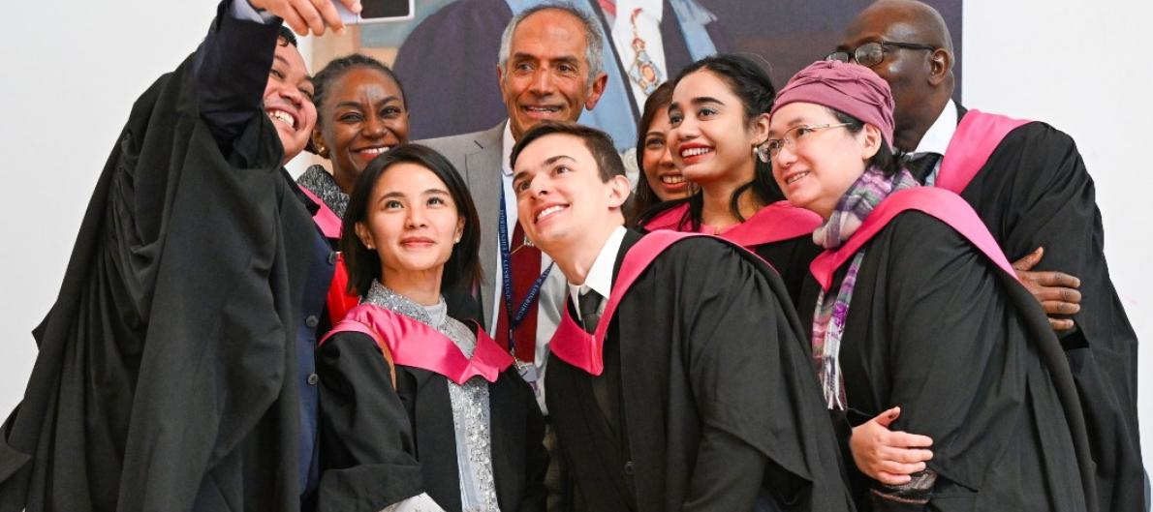
Some University of Edinburgh ChM Clinical Ophthalmology international graduates celebrating with Professor Bal Dhillon, Programme Director, at their reception at The Royal College of Surgeons of Edinburgh, 25 November 2023
The University of Edinburgh is delighted to announce that they plan to award 9 scholarships this summer for successful international applicants to their Master of Surgery (ChM) in Clinical Ophthalmology programme, thanks to the very generous support of The David and Molly Pyott Foundation.
Senior trainees/residents/registrars in Ophthalmology and early career ophthalmologists from low resource settings in Africa, Central and South Asia, Caribbean Islands, Pacific Islands, Central and Latin America who are accepted for admission to the online ChM programme commencing in September 2024 are eligible to apply for the scholarship award. This will cover all tuition fees as well as internet access and a laptop. Scholarship applications close on 1st June 2024.
The ChM is a two-year, part-time, online degree offered by the University of Edinburgh in partnership with the Royal College of Surgeons of Edinburgh (RCSEd) and is designed to support senior specialist trainees in ophthalmology in the United Kingdom and internationally by providing advanced education for those preparing for the fellowship examinations of RCSEd and the Royal College of Ophthalmologists and those approaching consultancy. Students can study in their home countries without having to take time out of practice or training, whilst continuing to deliver critical care in regions with ophthalmic workforce capacity issues.
The David and Molly Pyott Foundation has been funding this highly successful scholarship programme in partnership with the University since 2016. It has supported 57 trainee and qualified ophthalmologists (generalists and specialists) so far to undertake the ChM programme. Four scholars from Brazil, Nigeria, Zambia and Zimbabwe graduated in November 2023.
ChM programme information is available online, including an introductory video by Baljean Dhillon, Professor of Clinical Ophthalmology, University of Edinburgh, and ChM graduates’ video testimonials. The ChM is one of a number of Edinburgh Surgery Online Masters programmes delivered by the University in partnership with RCSEd. Scholarship applications must be received by 1st June 2024 23:59 BST. Applications for admission to the ChM close on 23rd August for September 2024 entry.
More information can be found here:
https://www.ed.ac.uk/clinical-sciences/ophthalmology/masters/
Contact: Dr Heather Ellis, Deputy Programme Director, ChM (Master of Surgery) in Clinical Ophthalmology and MSc in Primary Care Ophthalmology, University of Edinburgh
Email: heather.ellis@ed.ac.uk

